**HOSTING ERRORS**

**What Are Web Errors?**

Website errors are simply the problems that come from a misconfigured server. These are usually software, but rarely, you might find the issue is actually with the hardware. There are many errors defined in the HTTP specifications. Because of this, the errors are often quite easy to find and read about. You can quickly get information about what causes the error, which usually leads to an easy fix. However, you also need to understand that certain errors could potentially be because of other things. For example, getting hacked could lead to you getting specific software errors that could send you on a wild goose chase to solve the problem.

**How Do They Affect Your Website?**

The effect on your website is dramatic. You are going to lose a lot of SEO rankings and even have problems with customers. Uptime is one of the biggest factors in whether people visit your website or not. It can also be a huge problem for your sanity, as you will not get a lot of sleep if you spend a lot of time fixing your web error. When you get these problems happening to your site, you can find a website error checker online to see what is going on. You might also look at sources that teach you how to solve web page errors.

**HTTP Errors**

HTTP errors are usually the most prevalent on the Internet. They have to do with the software server going down to some issue. There are many types of them, and they each have specific things you need to do to solve. However, a simple browser errors list will give you a detailed guide with all the information you could ever want about these errors and what to do. However, there is one Internet page error that is so general that it is almost impossible to solve without deep digging into the specific software stack and server setup. You might even encounter a message that tells you that the website encountered an unexpected error please try again later.

**10 Most Common Website Errors and How to Fix Them**

**1. Error 404 Page Not Found**

The first and most popular server issue you will have is the page not being found. If you are working with static HTML pages, this error means you have not created the page you are trying to view. However, the majority of people use dynamic programming languages like PHP to create their websites. This allows them to use fancy server-based soft redirects in place of an actual page. However, when a web browser tries to go to a page that does not exist, it will throw this error. The easiest way to solve this error is to look in your public directory to see if the file exists. For content management systems, that means looking through all of your created content to check if one exists with that name. You will easily be able to tell with just a few minutes of searching.

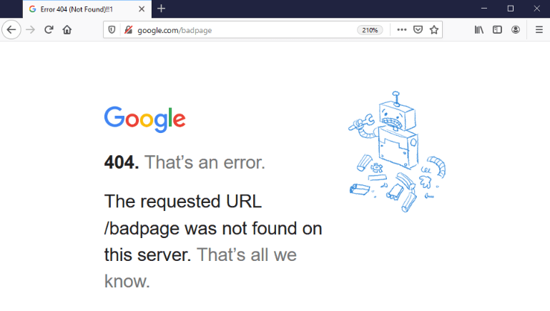

**2. Error 401 Forbidden**

This error has to do with permissions. Every operating system has a way of managing access to files. If a user doesn’t have access to these files, the operating system will throw an error message when they try to open the file. It also works with other attributes like updating the file, deleting the file, or even moving it. Linux has a robust file permission system, which comes up quite often in the web development world. When you are working with PHP and other dynamic software development tools, you can actually code file permissions based on your own access methods. For example, you can have a login page with content reserved for paying customers. When someone can visit this page without logging in, you will have to use the software to throw an error letting them know it is denied. The main method of solving this problem is to change the permissions of the file that cannot be accessed. It usually involves using cPanel or the Linux command line to do that.

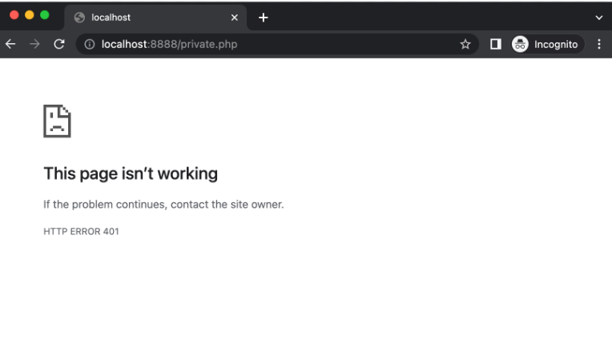

**3. Error 500 Internal Server Error**

This is one of the most difficult errors to solve because it is generic. An internal server problem could be anything. It usually involves sending the browser a message that says the website encountered an unexpected error please try again later. It is one of the most frustrating error messages that webmasters and users can receive. However, in the age of the Internet, we now have a wealth of resources to solve problems like these. The solution usually narrows down to getting as much information about your specific set up as possible. You are most likely to find someone who has the same or similar set up who has already solved the problem.

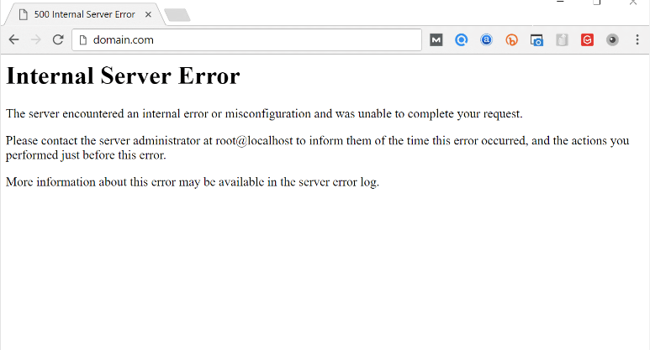

**4. Error 400 Bad Request**

This error is also generic, but there are some things you can check to make sure that you have solved them. It is most often associated with the browser caching system and the actual website. When you visit a webpage, your browser stores a copy of that webpage on your computer, so you can access it later without having to send another request. However, there will be times when that data is updated on the server, but your browser hasn’t caught up yet. This means there’s a huge difference between the request and the response. The server will detect that you are asking for a webpage that has changed dramatically, and it will throw this error. The key to solving this problem involves flushing your browser and DNS cache.

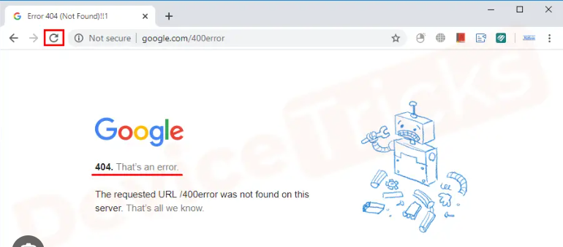

**5. Error 503 Service Unavailable**

A huge problem that can happen to your website is getting attacked by a DDOS or distributed denial of service. This is when someone floods your server with traffic that prevents legitimate visitors from browsing. It’s essentially bogging down your server software, and this is a common tactic by people to extort money from innocent website owners. The way to solve it is to get your website hooked up to a professional DDOS blocking service. They will be able to filter out every visitor to make sure that they are not part of a botnet network trying to take your website down. You should be careful with this type of error because it means you are a target for someone in your industry.

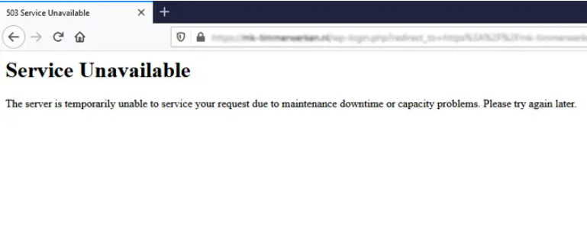

**6. Error 504 Bad Gateway**

This error occurs when your Web server is trying to act as a gateway for another server. It has a timeout period, which ensures that you don’t spend an infinite amount of time being stuck in a loop. It throws this error when that timeout period has been exhausted. However, the problem with this error is that it is often difficult to fix. It almost always goes away by restarting the server software, but it can remain because of misconfigured add-ons. This is something that you will have to check personally to make sure that everything is okay.

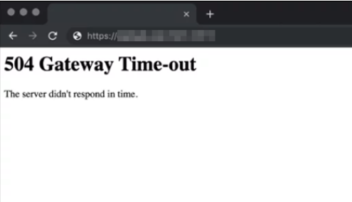

**7. Infinite Loading and Redirect Loop**

You might have a problem where your browser is stuck in an infinite loop when visiting your website. This is one of the most common problems with web browsers like Google Chrome. The easiest way to fix this problem is to simply go into the settings of the browser and reset the cache, history, and other associated systems. When you do that, you are much more likely to fix these problems. It is also a problem with the DNS cache, which would need the user flushing their DNS cache through the operating system.

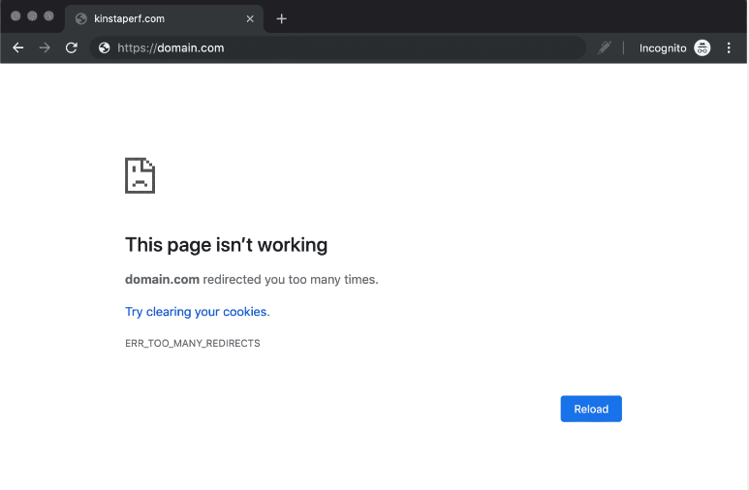

**8. Error 408 Request Timeout**

The big problem with this error code is that it could be a symptom of the server or the client. It essentially means that the Web server did not get a complete request in a specific period of time. It then throws his error to let you know that something went wrong. A request timeout could potentially mean that the website is under attack from hackers. That could be a denial of service or a distributed denial of service attack, which is common in today’s world. However, it can also mean a problem in the web browser that causes it to send incomplete data to the server when making a request. As a webmaster, you have to check to ensure that it is not coming from your server, but you can also disregard this error code if it is just coming from one client.

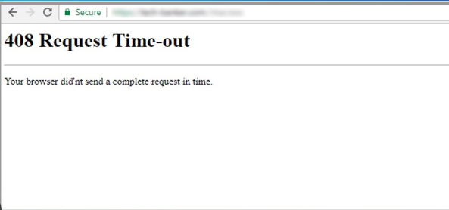

**9. Error 501 Not Implemented**

This record is quite rare, so it is one that you don’t have to worry about. The majority of commercial and open-source Web servers have implemented all features of the HTTP specification. If you ever have a server that doesn’t, the only thing you can do is change the server to one that does.

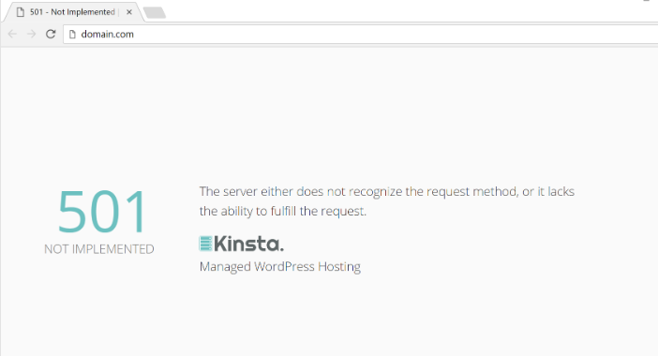

**10. 502 Website Temporarily Overloaded**

This is also the symptom of a denial of service attack. As a website owner, one thing you can do to solve this problem in the future is to route traffic to other servers when that happens. There are many services like Cloudflare that will help you with these types of attacks. They are experts, and they have their own hardware appliances for blocking these types of attacks.

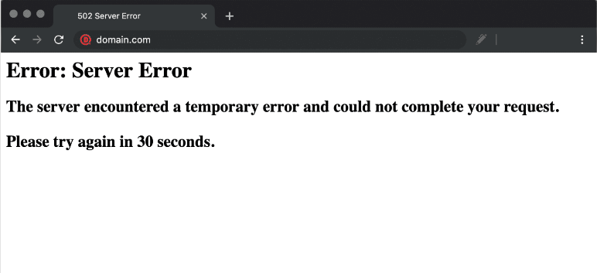

**11. 300 Multiple Choices**

The requested resource has multiple representations, and the server is unable to choose the most appropriate one. The response should include a list of alternatives.

**12. 301 Moved Permanently**

The requested resource has been permanently moved to a new URL. The client should update its bookmarks or links to the new URL.

**13. 302 Found (or 307 Temporary Redirect)**

The requested resource has been temporarily moved to a different URL. Unlike 301, this is a temporary redirect, and the client should continue to use the original URL for future requests.

**14. 303 See Other**

The server is redirecting the client to another resource, and the client should use a GET request to retrieve it.

**15. 304 Not Modified**

The client's cached version of the resource is still valid, and the server responds without sending the resource again. This is often used to reduce bandwidth usage.